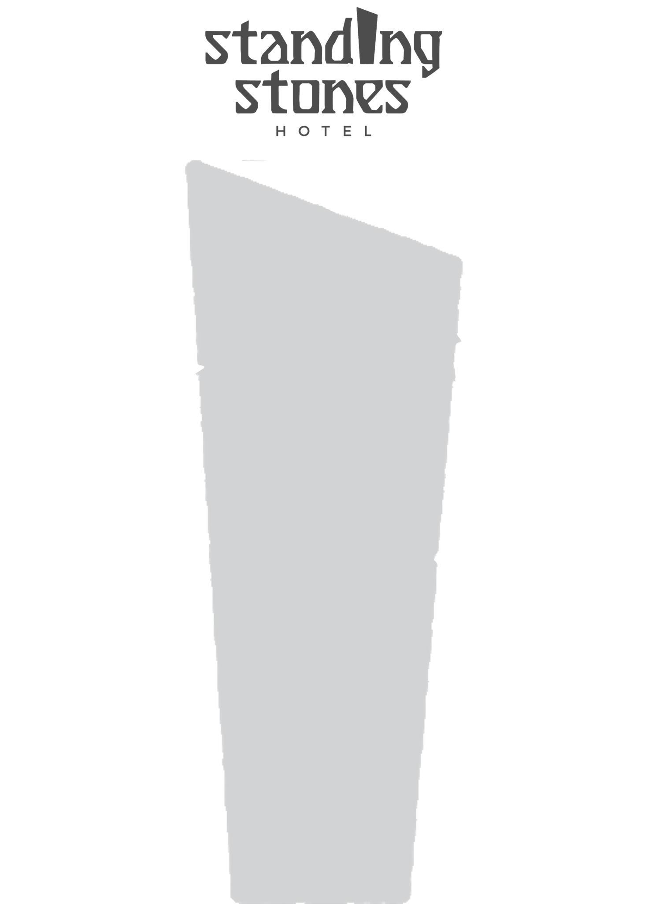

STARTERS

SOUP OF THE DAY (W)(V)(Ce)(+GF)(+Vg) £6.95
Served with seeded bread and butter.
Gluten free bread available.

CRUMBED ORKNEY GRIMBISTER CHEESE (D)(W)(V)(E)(N)(+GF) £9.25
Orkney Grimbister cheese, fried in a panko breadcrumb.
Served with chilli jam and a salad garnish.
Gluten free option available.

ROAST CHICKEN CROQUETTES (D)(W)(E)(MD) £8.95
Roast chicken, black pudding, apple, mashed potato and neep
croquettes, encased in a panko crumb. Served with a salad garnish
and a whisky mayonnaise.
Gluten free option available. Does not include black pudding.

PRAWN COCKTAIL (D)(SF)(E)(F)(+GF) £10.25
Prawns in a bloody Mary (0%acl) dressing, on a bed of
salad with seeded bread on the side.
Gluten free bread available.

All side salads served with honey mustard dressing.
Please advise your server of any allergies.

MAIN COURSES

SUNDAY ROAST (D)(S)(E)(Ce)(MD)(+GF) £18.25
Choose from the following options:
- Tender roast beef
- Succulent roast chicken
- Baked fillet of salmon
- Ask your server for the roast of the day
- Cranberry nut roast (W)(Vg)(P)(N)
Served with a rich gravy, seasonal vegetables, crispy roast potatoes,
mashed potatoes, stuffing and golden Yorkshire puddings.
Gluten free available on request.

FISH AND CHIPS (D)(W)(E)(F)(+GF) £18.50
Locally sourced haddock, served battered or breaded with
hand-cut chips, peas and tartar sauce.
Gluten free available on request.

SCAMPI AND CHIPS (W)(Sf)(E) £17.95
Breaded scampi served with a side salad and hand-cut chips.

STONES STEAK AND ORKNEY ALE CASSEROLE (W)(E)(Ce)(SD) £17.95
Locally sourced steak, served in a rich Dark Island ale sauce, topped
with a puff pastry lid. Served with Chef’s potatoes and vegetables.

HIGHLAND BURGER (D)(W)(S)(E)(Se)(MD) £18.45
BBQ burger, haggis, onion rings and salad, served with
BBQ sauce and hand-cut chips.

DESSERTS

APPLE AND CINNAMON CRUMBLE (D)(V)(GF)(+Vg) £8.25
Served with custard.

STICKY TOFFEE PUDDING (D)(V)(E)(SD)(GF) £8.25
Served with our homemade toffee sauce and
Orkney ice cream.

CHOCOLATE BROWNIE (D)(V)(E)(SD)(GF) £8.25
Served with vanilla Orkney ice cream, and warm chocolate sauce.

CHEESECAKE OF THE DAY (D)(W)(V)(N) £8.25
Ask your server about today’s delicious homemade cheesecake.
Served with almond shortbread biscuits.

TRIO OF ORKNEY ICE CREAM (D)(V)(GF)(+Vg) £ 7.80
Vanilla, Chocolate and Strawberry. (£2.60 per scoop)
Vegan ice cream available, vanilla only.

FRUIT SORBET (Vg)(V)(GF) £2.50 per scoop
Please ask your server for today’s selection.

TEAS AND COFFEES ALSO AVAILABLE

